1. Explain the “Question Ladder”. Also, prepare a Question Ladder to design an electric car for commercial use
2. Outline the term “Mind Map” and create it for the students appearing for the 12th class Examination.
3. Explain the concept of an Empathy Map and create one for a customer considering the purchase of a new smartwatch.
4. Explain the term “Engineering Design Process,” Also apply and design an
   1. Petrol car using the engineering design process.
5. Design a new mobile concerning Dieter Ram’s 10 Principles of Good Design.
6. Consider "Electric bike" as a product and explain how the SCAMPER method can be used to improve its design. Use diagrams or examples to support your ideas.
7. Explain the term “Design for maintenance” and apply this concept to the maintenance of a Bike.
8. What are various product architectures? Compare product architecture of whiteboard marker and blackboard chalk in terms of cost of maintenance.
9. What do you mean by Usability testing? Consider an example of a laptop and perform the usability test. “Create a rough sketch of the laptop.”
10. Explain the Design Thinking Process. What are various ways, processes and toolboxes for enhancing design thinking?
11. Enumerate the various elements considered while designing for aesthetics.
12. Explain the given Venn Diagram with an Example.

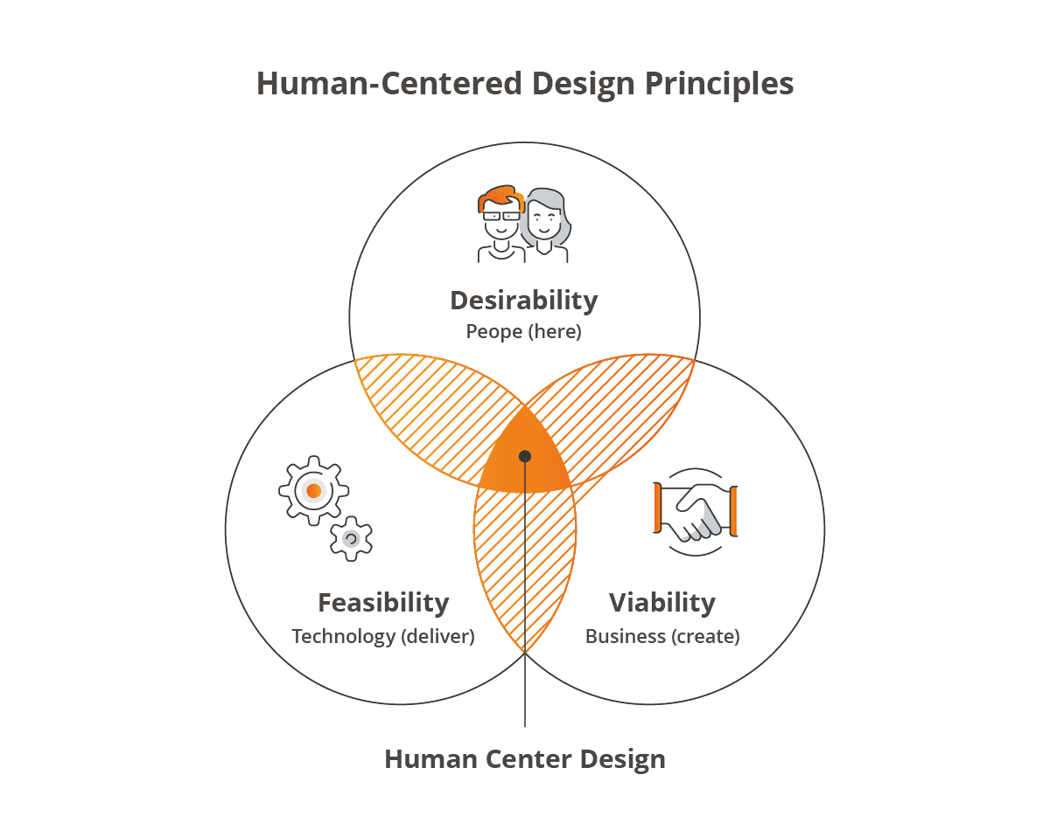

1. Explain “codes” and “standards” with examples.
2. What is the need of customer co-creation? Recommend some products where this user experience can bring sustainable solutions
3. Illustrate the term “Design for production” and how it impacts the productivity and design of any product.
4. By placing the user at the center of your decisions, design a suitable product of your choice using the "Human-Centered Design (HCD)" framework.
5. Explain conceptual design and all its types with neat sketches.
6. Outline the term “Life Cycle Assessment” and explain it with an example of your own choice.
7. Create a mind map for designing a mobile app that promotes eco-friendly behaviour among users, such as tracking carbon footprints or encouraging sustainable practices.
8. These flying machines of Leonardo Da Vinci are the earliest biomimicry example.

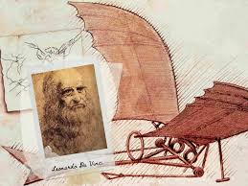

* 1. Draw neat sketch and label parts that form this flying machine resembling a bird.

1. Outline the term “Life cycle assessment (LCA)” and explain the importance of “LCA” in the industry 4.0 outcome for sustainable industrial solutions.
2. Explain social innovation and its need in engineering design and modelling.
3. Outline the term “Biomimicry.” What is the most suitable biomimetic example for
   1. the Japanese bullet train?
4. Apply this to the development of a “cooking oil “Utilize the engineering design process to design a new coffee mug. (Draw a sketch)
5. Investigate on various principles of sustainable design with suitable examples.
6. Consider a suitable example and specify the difference between adaptive design

and re-design

1. Investigate on “Biomimicry” and explain it in five real-time examples.
2. What is Embodiment Design? Write down the seven steps of formulating a laptop design at its parametric stage.
3. Describe the terms “Design of recyclability” and “Design for sustainability.”
4. What do You mean by “Aesthetic design.” Explain the use of aesthetic design
   1. for designing the product shown in Figure.



  